

**Above one is final logo in pdf, word/editable is below____**

LET’S COLOUR THE WORLD …

**RIDDHI DYECHEM IMPEX**

**Since 1995**



|  |
| --- |
| To move the above editable logo: |
| 1. Place the world map first where you want 2. Then place other curved texted box i.e. RDI, 1995 & Lets color… |

RIDDHI DYECHEM IMPEX

**Coloring the World**



**RIDDHI DYECHEM IMPEX**

Coloring the World

Coloring the World



 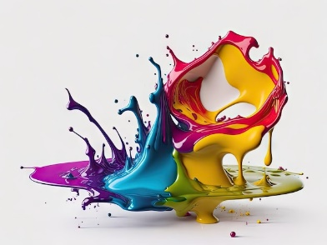

Coloring the World…



